|  |  |
| --- | --- |
| **NAME: Rahul Thambi** | **Roll Number: A059** |
| **SUBJECT: Visual Analytics** | **CASE STUDY** |

**TOPIC: ADIDAS SALES ANALYSIS IN USA**

|  |  |
| --- | --- |
| **TOPIC** | **PAGE NUMBER** |
| INTRODUCTION TO DATASET | **1** |
| DATA ACQUISTION / PRE-PROCESSING | **2, 3** |
| ANALYSIS ON TABLEAU | **4 - 22** |
| CONCLUSION | **22** |

**INTRODUCTION:**

**Company background**: Adidas is a German multinational corporation that designs and manufactures shoes, apparel, hardware, and accessories. It is the largest sportswear manufacturer in Europe, and the second largest in the world, after Nike. Adidas'sproducts are traditionally marked with a three-stripe trademark, which remains an element in the company's newer “trefoil” and “mountain” logos. Adidas was founded in 1949 by Adolf (“Adi”) Dassler after he split from his brother Rudolf (“Rudi”) Dassler, who founded Puma.

Adidas produces a wide range of products, including:

Footwear: Adidas is best known for its athletic footwear, which is used by athletes in a variety of sports, including running, soccer, basketball, and tennis. The company also produces casual and lifestyle shoes.

Apparel: Adidas produces a wide range of apparel, including t-shirts, jackets, hoodies, pants, and leggings. The company's apparel is often used by athletes, but it is also popular among people who are not involved in sports.

Hardware: Adidas produces a variety of hardware products, including soccer balls, basketballs, and golf balls. The company also produces fitness equipment, such as treadmills and elliptical machines.

Accessories: Adidas produces a variety of accessories, including bags, socks, and hats. The company also produces sports equipment, such as shin guards and cleats.

Adidas is a global brand, and its products are sold in over 160 countries. The company has a strong presence in both the athletic and lifestyle markets. Adidas is also a major sponsor of sporting events, including the Olympic Games and the FIFA World Cup.

**About the dataset:** An Adidas sales dataset is a collection of data that includes information on the sales of Adidas products. This type of dataset may include details such as the number of units sold, the total sales revenue, the location of the sales, the type of product sold, and any other relevant information.

Adidas sales data can be useful for a variety of purposes, such as analyzing sales trends, identifying successful products or marketing campaigns, and developing strategies for future sales. It can also be used to compare Adidas sales to those of competitors, or to analyze the effectiveness of different marketing or sales channels.

There are a variety of sources that could potentially provide an Adidas sales dataset, including Adidas itself, market research firms, government agencies, or other organizations that track sales data. The specific data points included in an Adidas sales dataset may vary depending on the source and the purpose for which it is being used.

**DATA ACQUISTION (TYPE OF CATEGORIES):**

Retailers: String type

Retailer id: String type

Invoice Date: String type

State: String type

City: String type

Product: String type

Price per unit: int type

Units sold: int type

Total Sale: int type

Operating profit: int type

Operating Margin: int type

Sales Method: String type

**FINAL CONCLUSION:**

**LINK TO DATASET:** [**https://www.kaggle.com/datasets/heemalichaudhari/adidas-sales-dataset**](https://www.kaggle.com/datasets/heemalichaudhari/adidas-sales-dataset)

**Pre-Processing step:** There were in total **10,237** rows in the adidas-sales-dataset, out of them **584** rows had missing values, by importing the dataset on google collab and using the below code, we removed those missing values and the final count of the dataset was thus **9653**. Total columns stays the same i.e. **14**

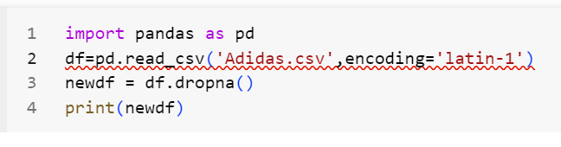

**Analysis on Tableau:**

**Rahul – A059:**

**Total Sales in Each City:**

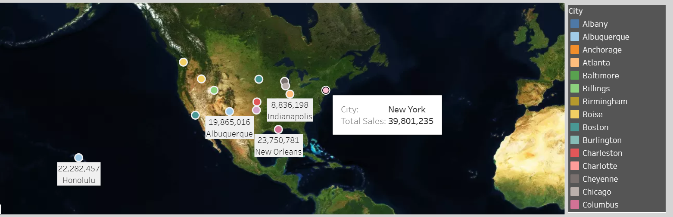

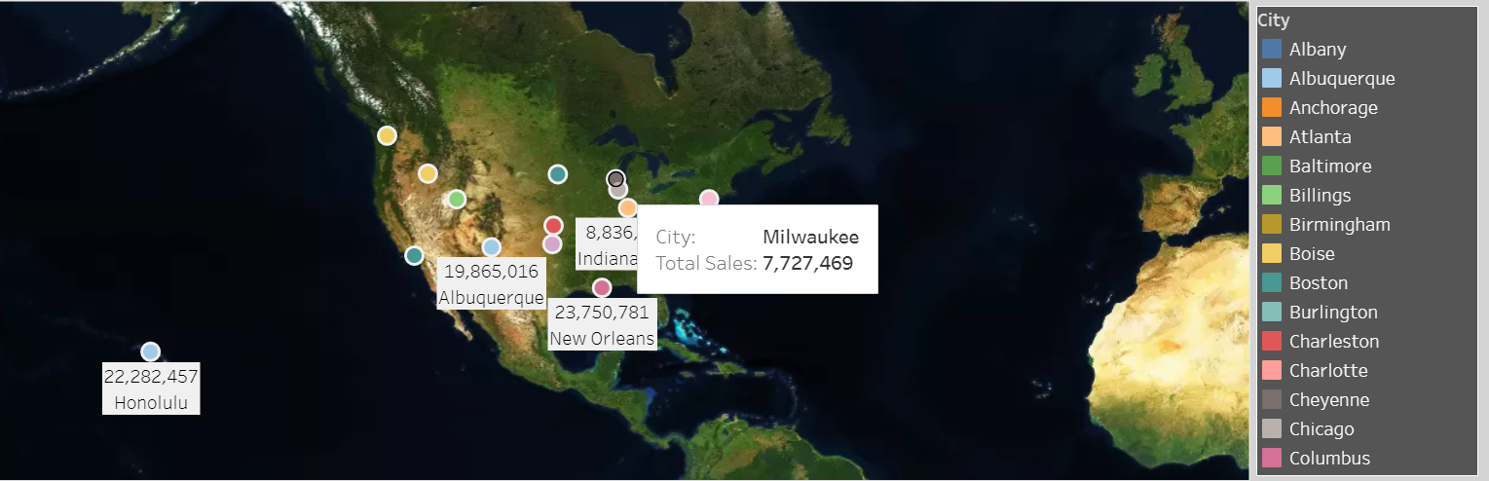

**Purpose:** This graph displays total sales in different cities on a world map.

**Analysis**: It helps you identify the geographical distribution of sales and find high-performing and low-performing cities. This can provide insights into where your retail operations are thriving and where they might need improvement.

In the above map, we have tried to visualize, the total sales in each city in the country of united staes of America. We can see that newyork has the maximum total sales of over 39million adidas product, whereas milwaukee has the lowest total sales of almost 7.7 million.

**Trends of operating margin over time:**

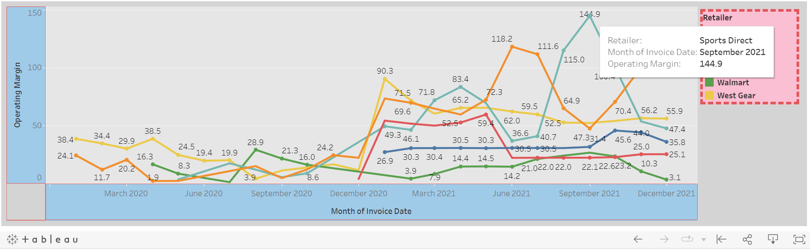

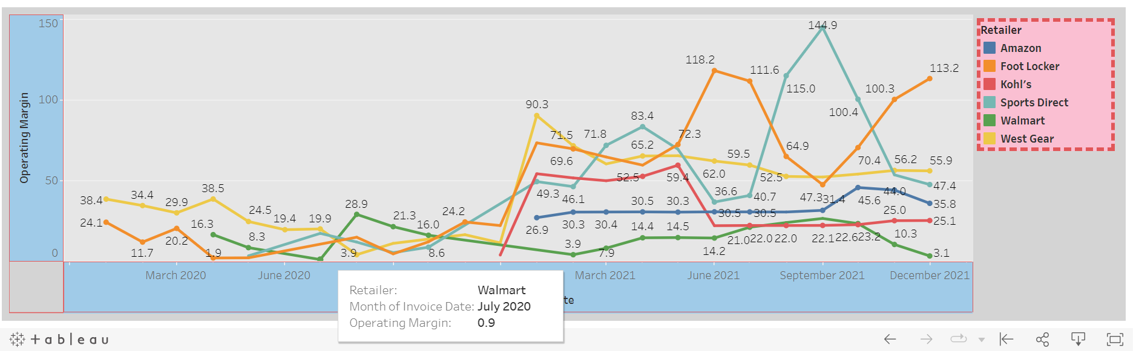

**Purpose:** This line chart shows the trends in operating margin over time.

**Analysis:** It enables you to track how the operating margin has evolved over time. You can identify periods of growth or decline and correlate these trends with any changes in business strategies or external factors.

From the above line chart, we can observe how over time, the operating margin of different retailers (Amazon, Foot locker, Kohl's, sports direct, walmart, west gear). we can observe that the highest operating margin was of Sports direct in september 2021, and the operating margin was of 144.9. Wheras the lowest operating margin was of 0.9 for walmart in july of 2020.

**Profitability Rating: retailers and their number of units sold, differentiated by the profitability rating (high=0.5>, medium=<0.5)**

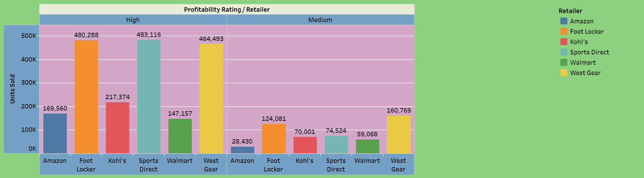

**Purpose**: This bar chart differentiates retailers by their profitability rating (high, medium).

**Analysis:** It helps you understand the distribution of retailers in terms of profitability rating and their number of units sold. You can identify the number of high and medium profitability-rated retailers and assess whether there's a correlation between profitability rating and sales performance**.**

In the above bar graph, we are comparing the different retailers and the number of units they have sold, we have also differed them as high and medium graphs based on the profitability for the retailer. If we observe we can see that under high profitabilty rating the maximum units was solf by Sports Direct whereas the lowest number of units solf is by Walmart. Wheras under medium profitability rating the highest number of units sold is by Foot Locker, whereas Amazon has the least number of units sold. It means that Footlocker has the overall best profitability rating for both medium and high rating conditions. By creating a new calculated field to segregate profitability to medium and high, we can achieve this.

**Regional Comparison:**

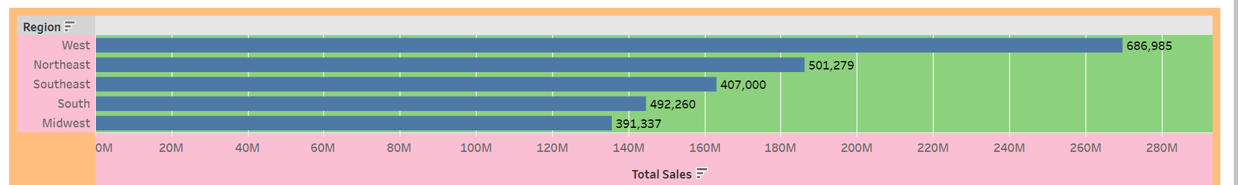

**Purpose**: This bar chart shows total sales by region.

**Analysis**: It allows you to compare the total sales across different regions. You can determine which regions are the top revenue generators and which regions might need further attention or investment.

In the above bar graph, we can observe how different regions in united states of America compare with the total sales of Adidas products. We can see that west has the maximum number of units sold (686,985), whereas the Midwest have the least number of units sold (391,337).

**Dashboard:**

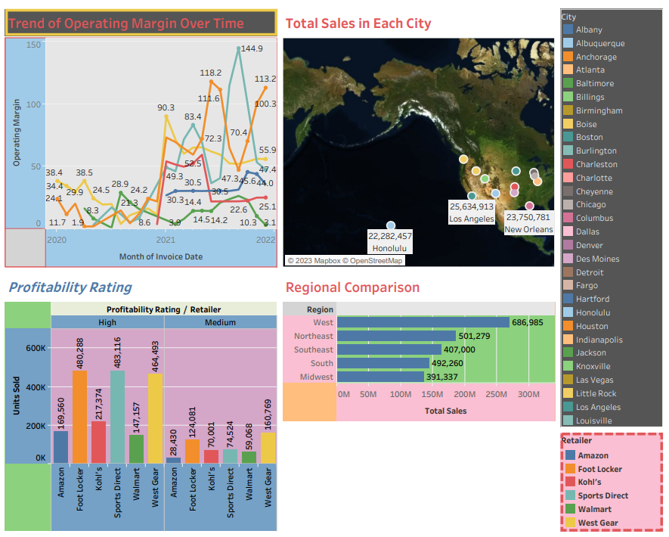

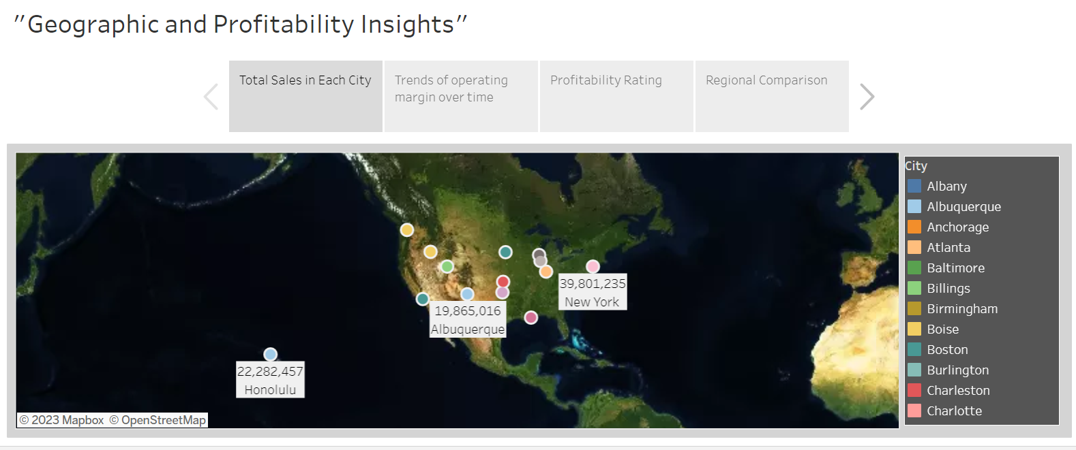

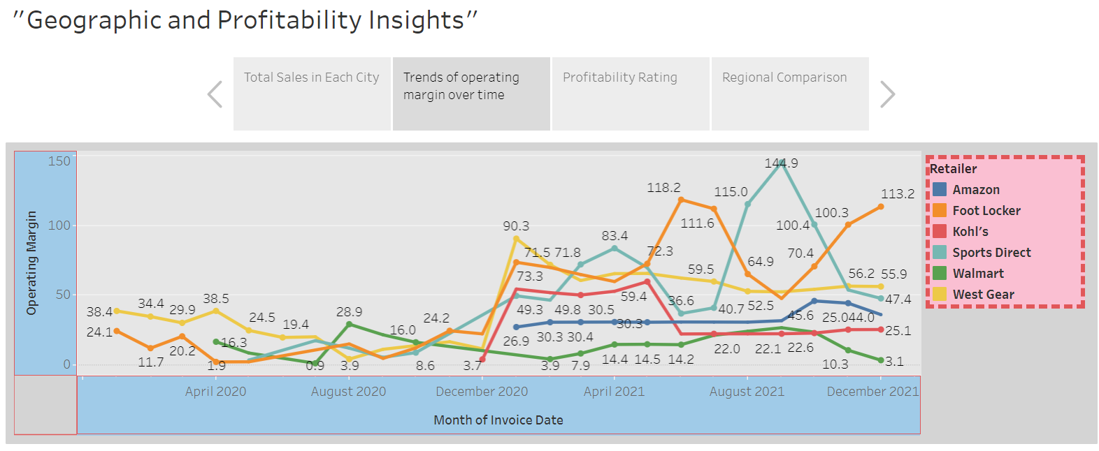

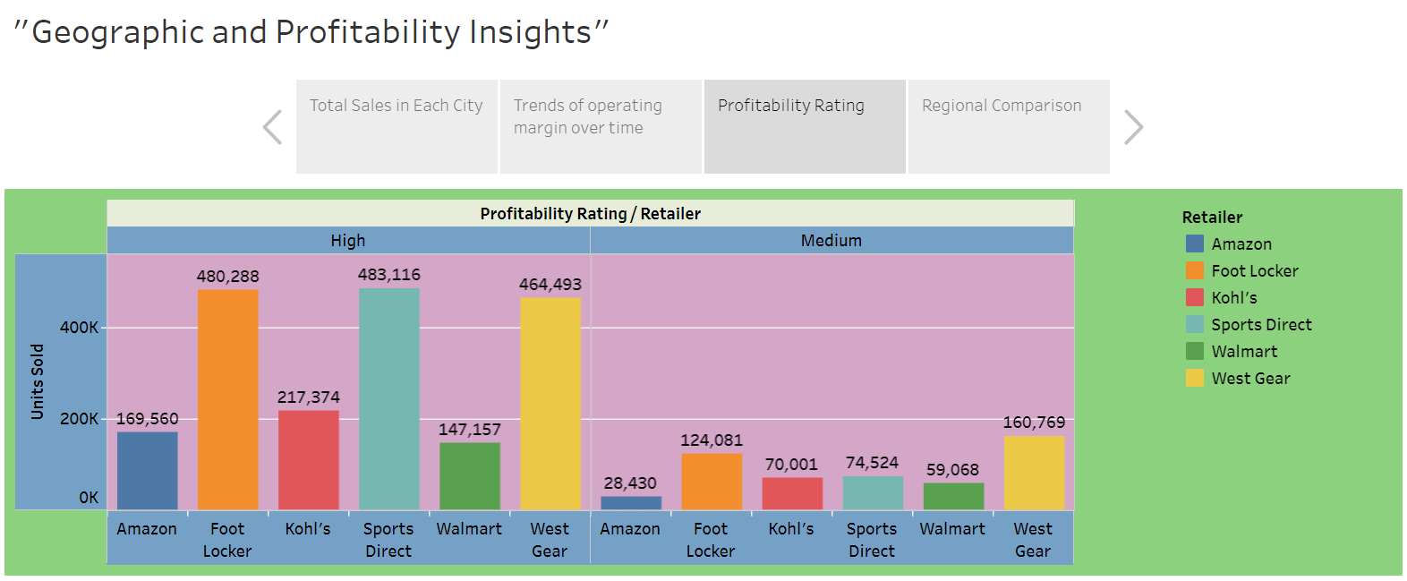 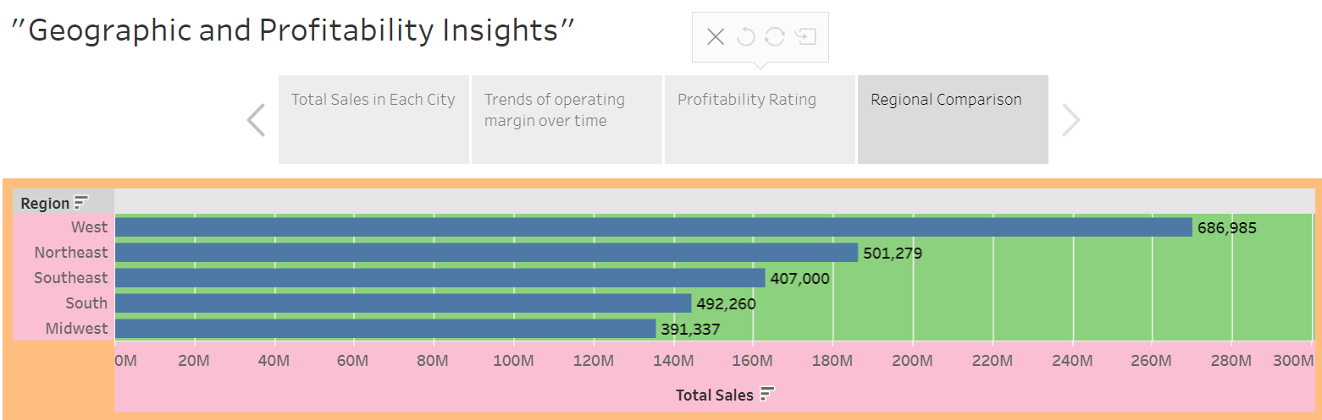

**Objective:** The goal of the Retailers Performance Analysis is to provide a holistic view of retailer performance by examining sales, profitability, regional distribution, and historical trends in operating margin.

**Conclusion:** By integrating these visualizations, the Retailers Performance Analysis equips us with a comprehensive understanding of our retail operations. It allows us to make data-driven decisions related to location-specific tactics, historical profitability trends, the relationship between profitability and sales, and regional performance. These insights can inform strategies to enhance sales, optimize profitability, and allocate resources effectively, ultimately improving our overall retail performance.

**RAJ – A072:**

**Graph 1: Tree Map for Retailers vs. Total Sales**

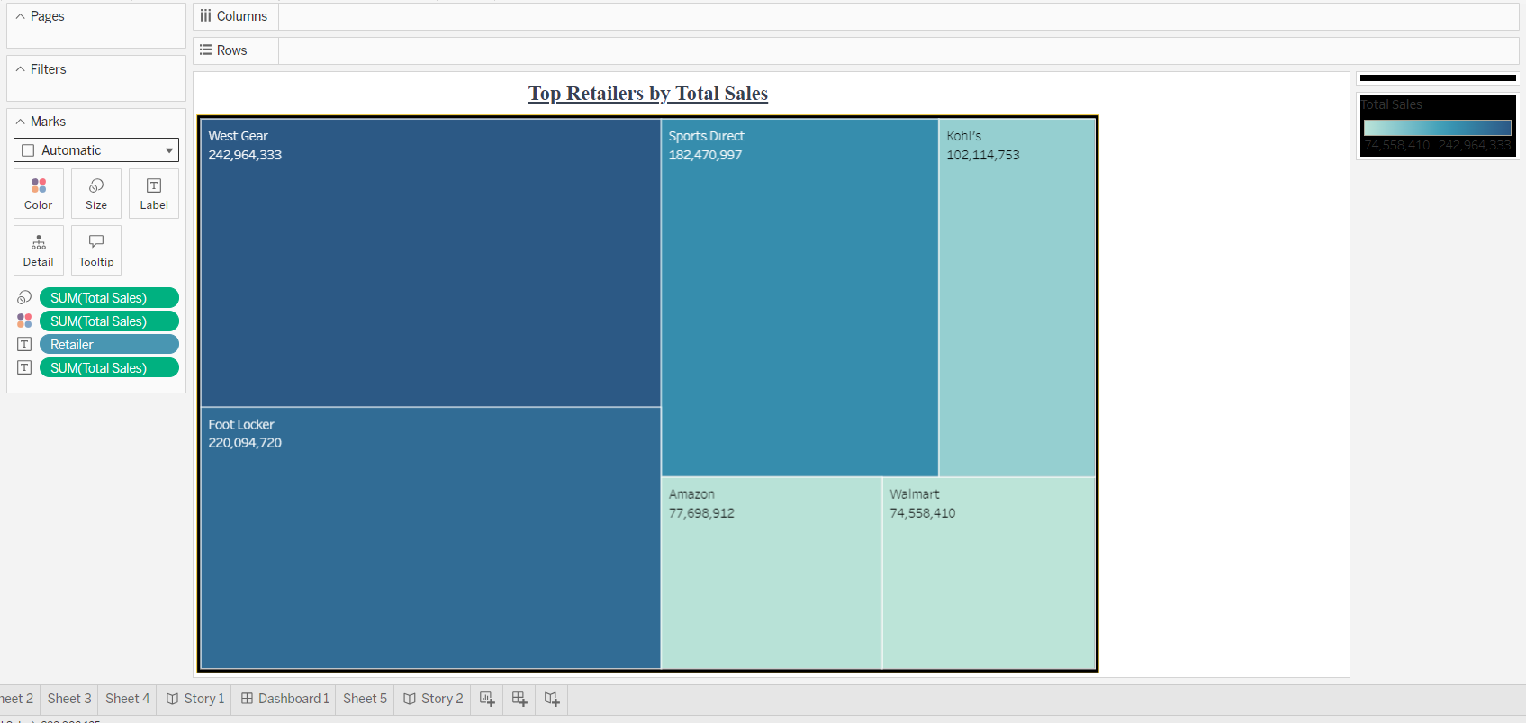

**Purpose:** This graph provides a visual overview of retailers and their total sales, with the size of each rectangle representing the relative magnitude of sales.

**Analysis:** It helps in identifying the top-performing and lowest-performing retailers. In your case, West Gear is the top retailer, and Walmart is the lowest.

**Graph 2: Bar Chart for Total Sales vs. Retailers in a Region**

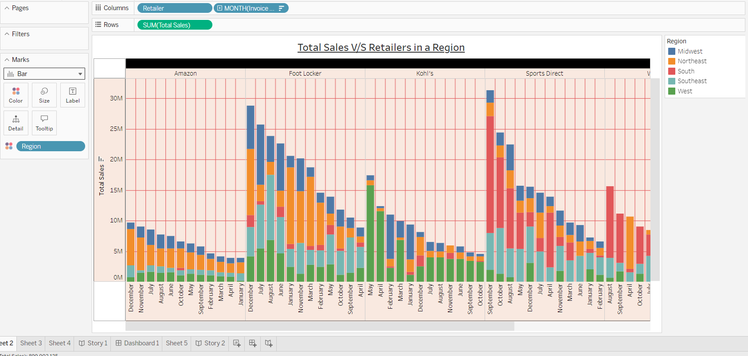

**Purpose:** This graph presents a comparison of total sales among different retailers within a specific region.

**Analysis:** It allows you to analyze how retailers perform within a specific region. You can identify which retailers are the top sales contributors in each region.

**Graph 3: Bubble Chart for Retailer vs. Operating Profit Margin**

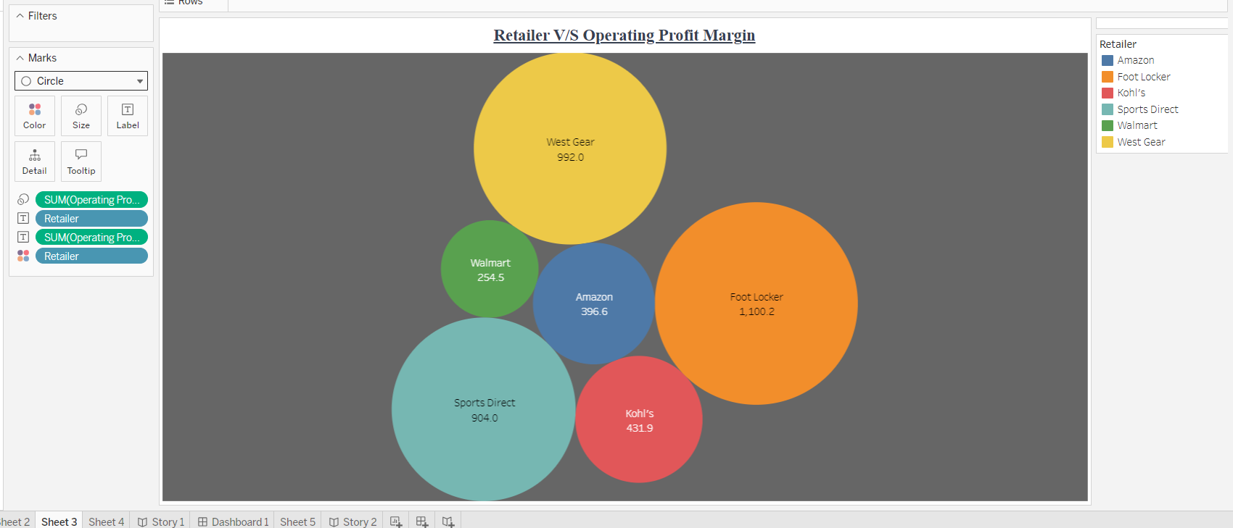

**Purpose**: This chart visualizes retailers based on their operating profit margin and total sales using bubbles.

**Analysis:** It helps you understand the relationship between a retailer's sales and their profit margin. Are there retailers with high sales but low profit margins? Are there retailers with lower sales but high profit margins? This can provide insights into profitability. According to this chart we can see that operating profit of west gear is highest (992) and Walmart is lowest (254.5).

**Graph 4: Bar Chart for State vs. Total Sales by a Retailer**

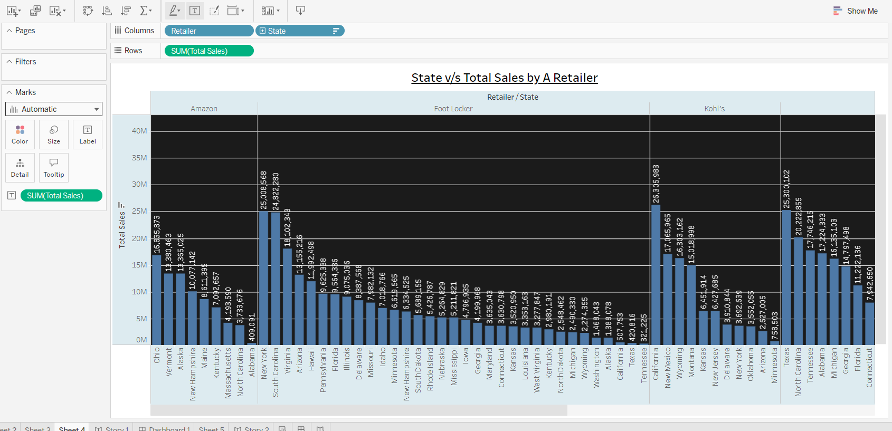

**Purpose:** This graph shows the total sales of a specific retailer across different states.

**Analysis:** It helps you identify the states where a particular retailer is performing exceptionally well or struggling. This can be crucial for strategic decisions, such as expansion or targeting specific markets.

**DASHBOARD:**

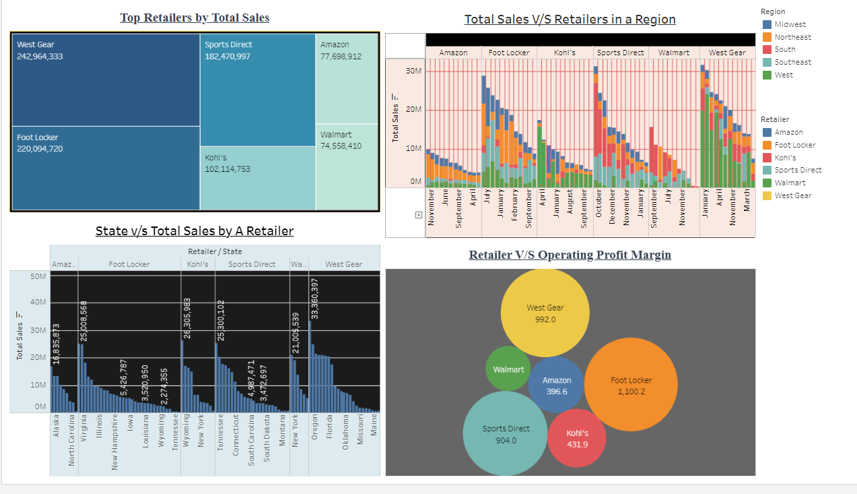

**Objective:** The objective of the Retailers Performance Analysis is to provide a comprehensive view of how different retailers are performing in terms of their total sales, profitability, regional strengths, and areas of improvement. By examining a variety of visualizations, we can gain valuable insights into the retail landscape.

**Conclusion:** By analyzing these four visualizations together, we gain a multifaceted understanding of retailers' performance. We can identify who the top and bottom performers are, assess their regional strengths and weaknesses, understand the relationship between sales and profitability, and recognize the most lucrative states for each retailer.

This analysis empowers decision-makers to develop strategies to enhance overall retail performance, allocate resources effectively, and optimize operations. It also guides retailers in tailoring their approach to specific regions and markets, leading to improved sales, profitability, and market presence.

**USER STORY:**

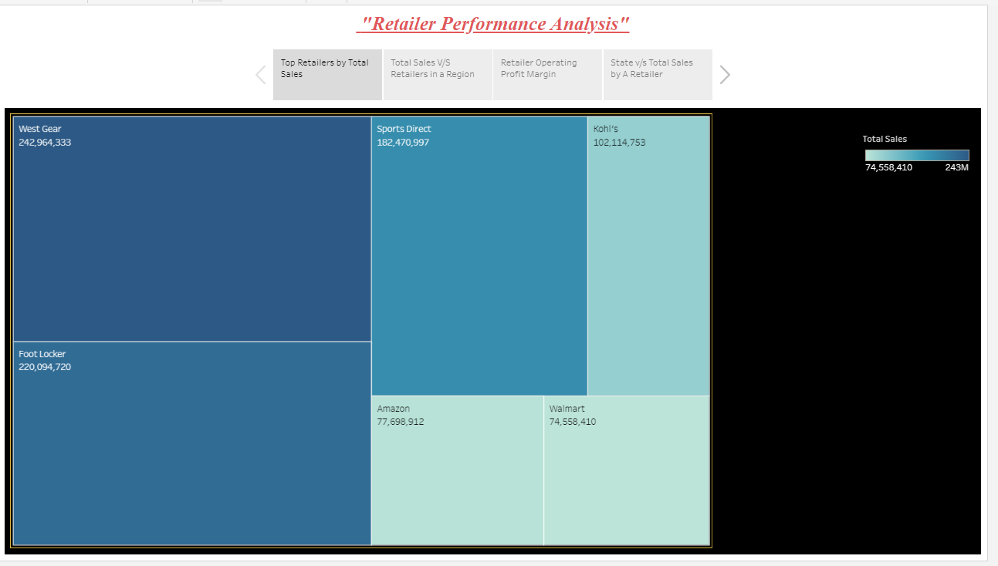

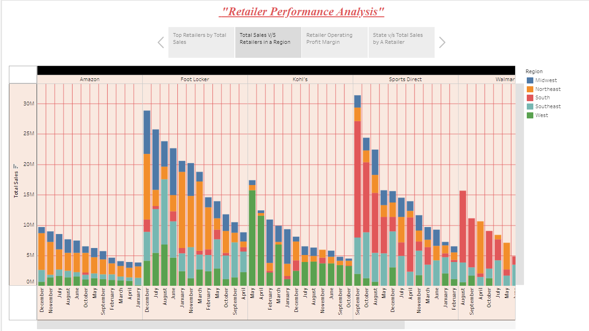

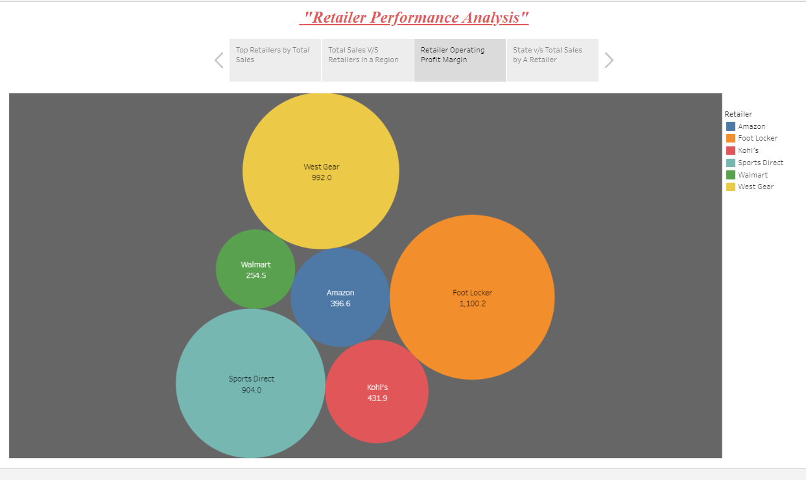

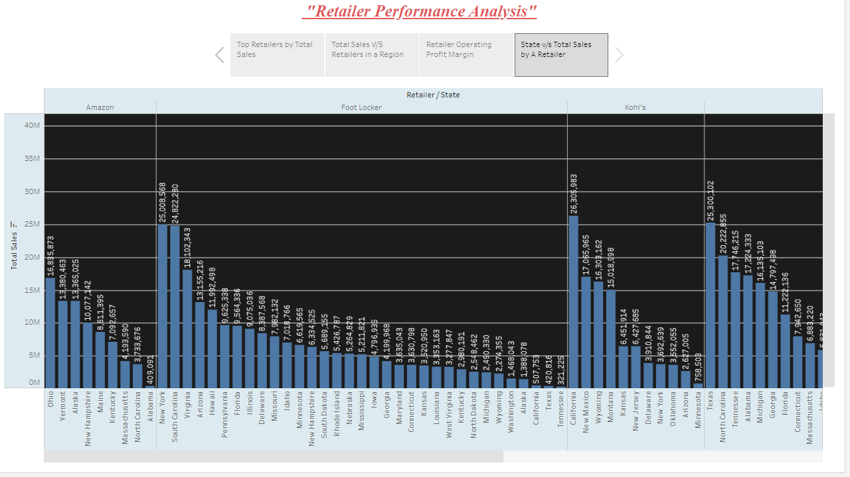

**Nikhil A040:**

Graph 1:

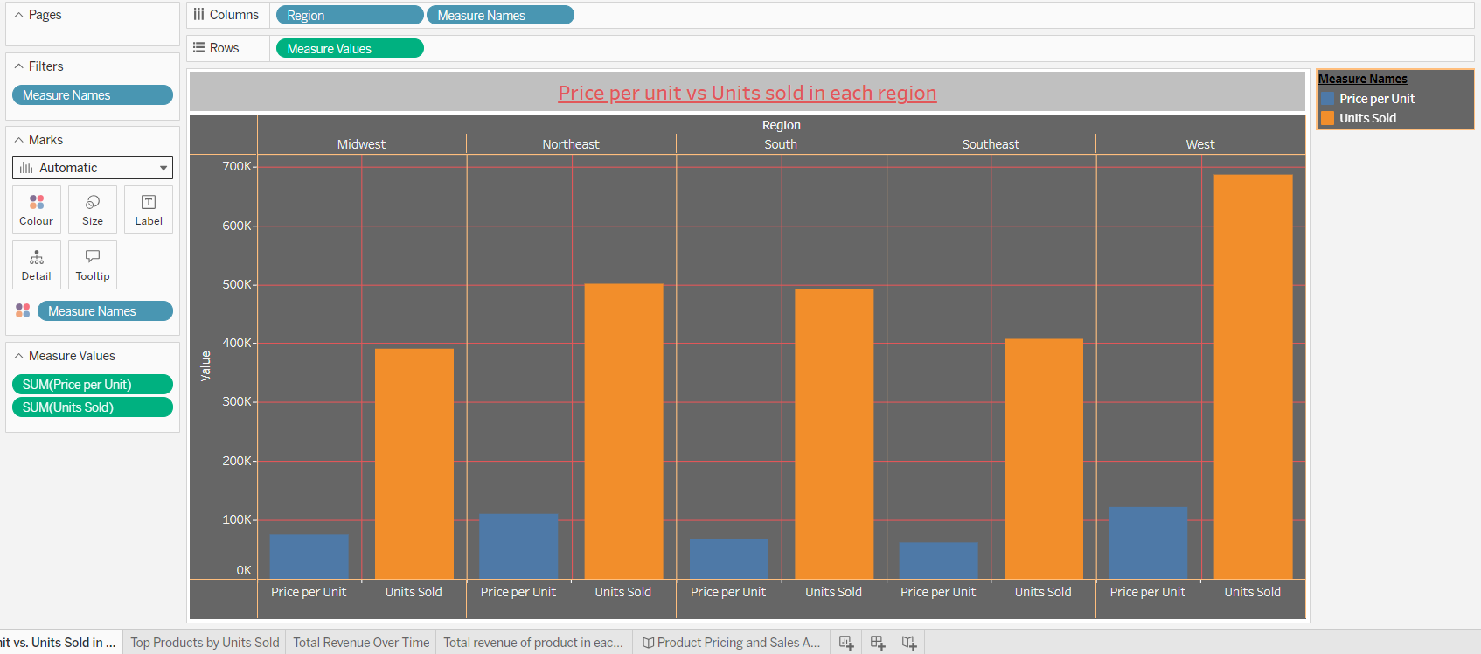

**Purpose:** This graph displays the price per unit of a product v/s the units sold in that region

**Analysis:** This graph helps us understand and get a overview of the number of units sold in a region and the sum of the price per unit in that region. This can help the new entrants price their product depending on their competitors in that region and it will also help the competitors to come up with strategies to gain the maximum profit in a region. This graph shows us that West has the highest units sold and Midwest has the lowest.

Graph 2:

**Purpose:** It shows the units sold of the top products

**Analysis:** This graph shows which product segment is doing the best. It shows the market share captured by each product category and which product segment has the highest number of units sold. This pie chart shows that men’s street footwear has the highest number of units sold while men’s apparel has the lowest number of units sold. It can also help businesses target the most appropriate product segment.

Graph 3:

**Purpose:** It shows the total revenue over time.

**Analysis:** This graph shows the change of revenue over time from march 2020 – December 2021. Revenue is the price per unit multiplied by the units sold. It shows how the total revenue is lowest in March 2020 and reaches it’s peak July 2021. It helps get a overall view of how the market has been doing over the year.

Graph 4:

**Purpose:** This shows the total revenue in each region.

**Analysis:** This graph shows the total revenue of all the products sold in that region. It helps get an overview of the total revenue sales of all the products in the particular region. West show the highest revenue. It helps get a insight into the market.

Dashboard:

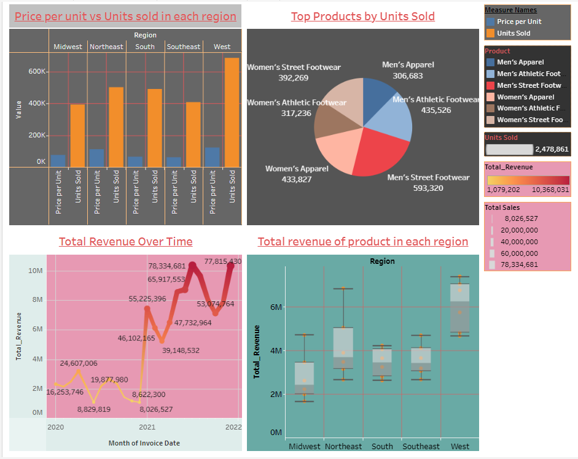

**Objective:** The objective of these Tableau visualizations is to provide a comprehensive overview of product sales and revenue data, enabling businesses to make informed decisions, develop pricing strategies, and focus their efforts on the most profitable product segments and regions.

**Conclusion:** In summary, the Tableau visualizations presented offer a comprehensive analysis of product sales and revenue trends across regions. They enable businesses to make informed decisions about pricing strategies, product segment targeting, and resource allocation. Notably, the data highlights regional variations in sales performance, with the West region emerging as a particularly strong market. These insights can guide both new entrants and existing competitors, helping them adapt to changing market conditions, maximize profitability, and optimize their strategies for sustained success.

**User Stories:**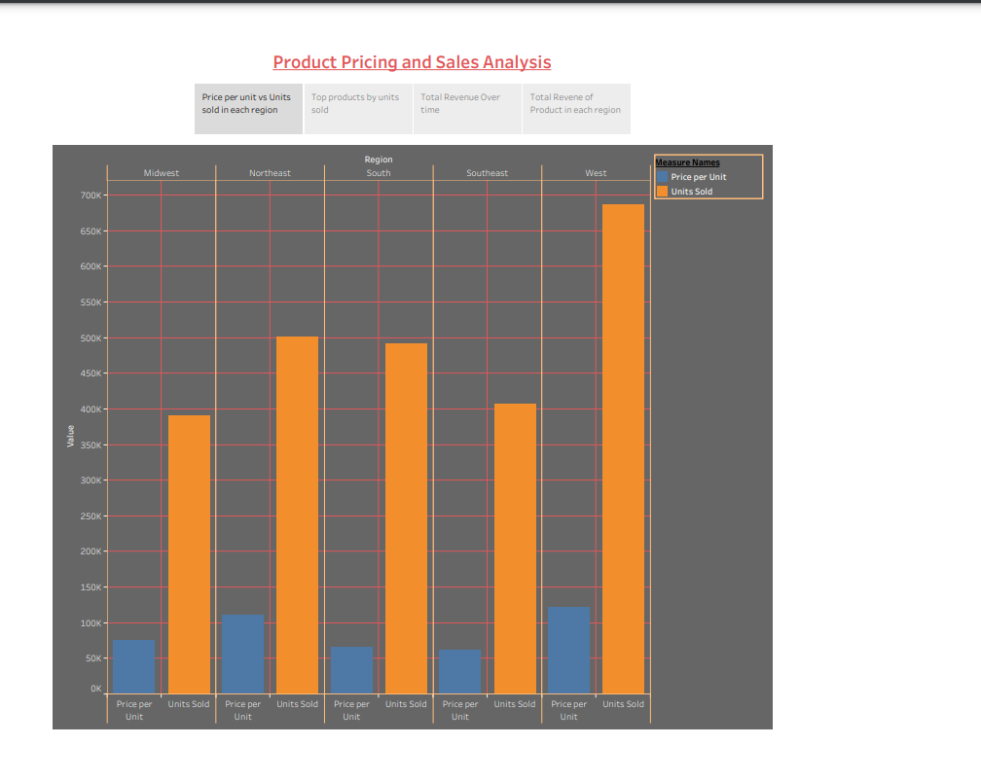

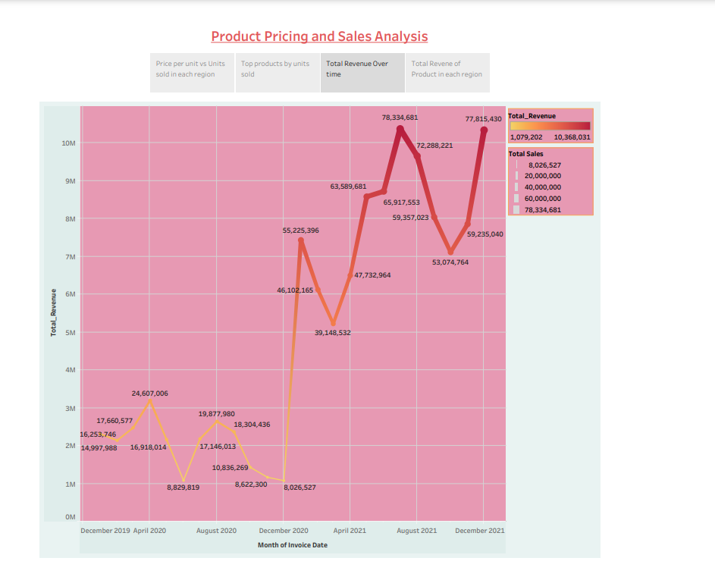

**PARTH – A007**

**Graph 1: Trend of Units Sold Over Time**

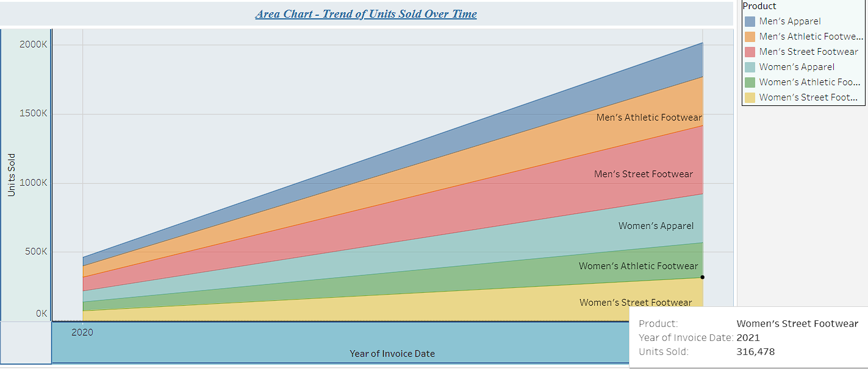

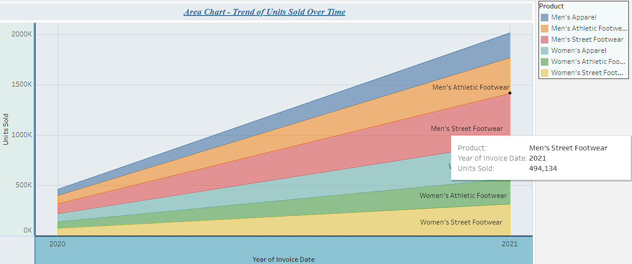

**Purpose**: This Graph shows about the total product sold over the Time

**Analysis:** The area chart illustrates the trend of units sold over time. The chart shows a consistent increase in units sold from the beginning to the end of the time period, indicating a positive sales trajectory. This suggests a healthy and growing demand for the product or service, making it a favorable market trend for the business to capitalize on. In these as we can see Product Men’s Street Footwear units sold were 494,134 which is highest among all the Products

**Graph 2: Price Distribution by Product:**

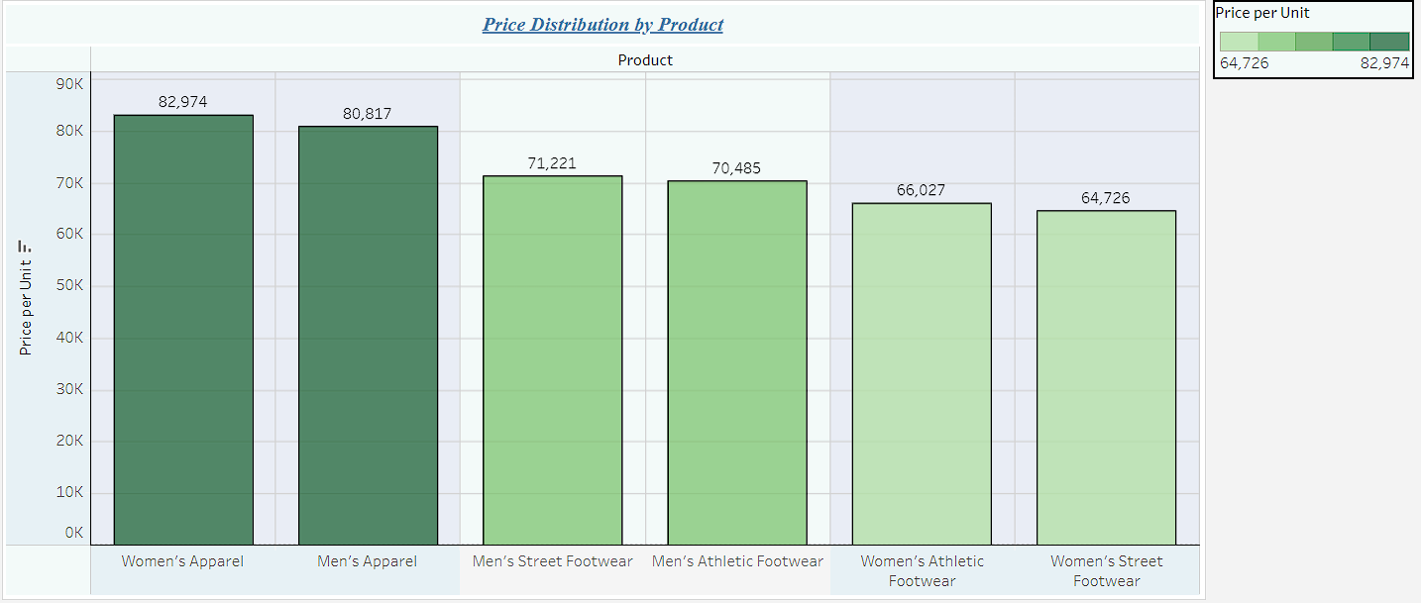

**Purpose:** These Bar Graph shows about Price Distribution over Product

**Analysis:** The bar chart displays the price distribution by product, with each product represented by a separate bar. It provides a visual overview of how prices vary across different products. This chart is useful for identifying price disparities, understanding the price range for each product, and making pricing strategy decisions based on market demand and product positioning. So in Bar chart we can see Women’s Apparel price was highest 82,974 compare by others Products

**Graph 3: Revenue by Product:**

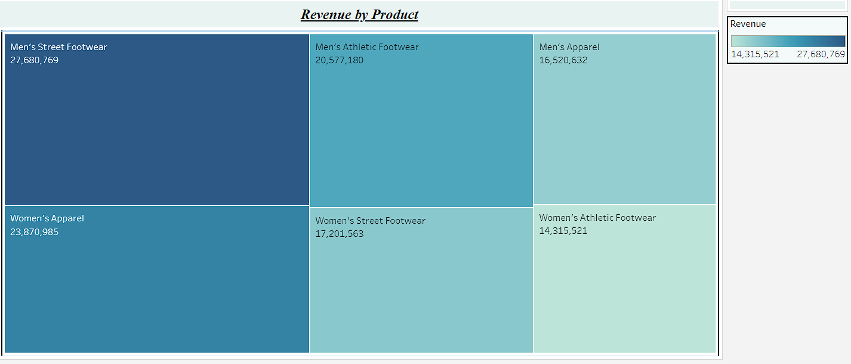

**Purpose**: So these graph shows about revenue generated by each product

**Analysis:** A calculated field for "Revenue by Product" typically involves multiplying the quantity sold of each product by its corresponding price. This results in a value that represents the total revenue generated by each product. This calculation is crucial for understanding the contribution of each product to overall revenue and can guide decisions related to product focus, pricing strategies, and profitability analysis. In these we can see the revenue of different product that were sold like we can see men’s street footwear were nearly around27 lakhs and women’s apparel were 23 lakhs

**Graph 4: Units Sold Distribution:**

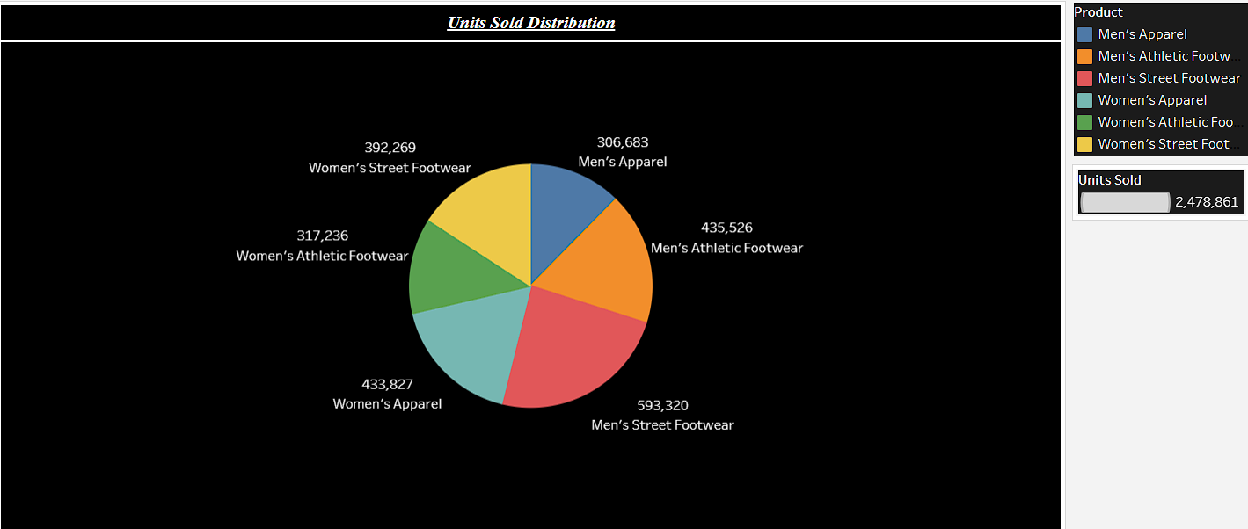

**Purpose:** So in these pie chart it shows about Unit sold Distribution

**Analysis:** A pie chart represents the distribution of units sold among different categories or products. Each "slice" of the pie represents a product or category, and the size of each slice corresponds to the proportion of units sold. This chart provides a clear visual of how units are distributed among various items, helping to identify which products are the most and least popular so in these we can see the most popular was men’s street footwear and least popular was men’s apparel

**DASHBOARD:**

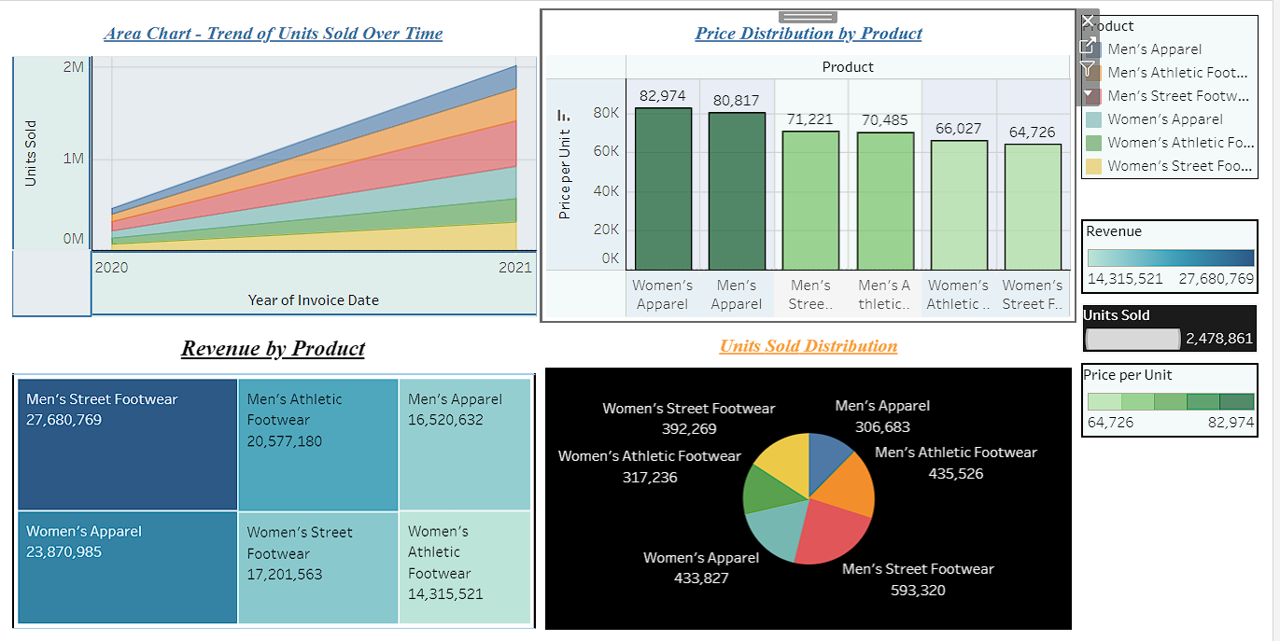

**Objective:**

The objective of creating these four graphs under the title "Product Performance and Pricing Strategy" is to comprehensively assess the performance of different products, understand their pricing distribution, and derive insights for formulating effective pricing strategies.

**Conclusions:**

The analysis of these graphs reveals that the business is experiencing a positive trend in units sold over time, with certain products contributing significantly to overall revenue. Price distribution indicates opportunities for optimizing pricing strategies. It is crucial to focus resources and marketing efforts on high-performing products while strategically adjusting prices to enhance profitability and market competitiveness.

**USER STORY:**

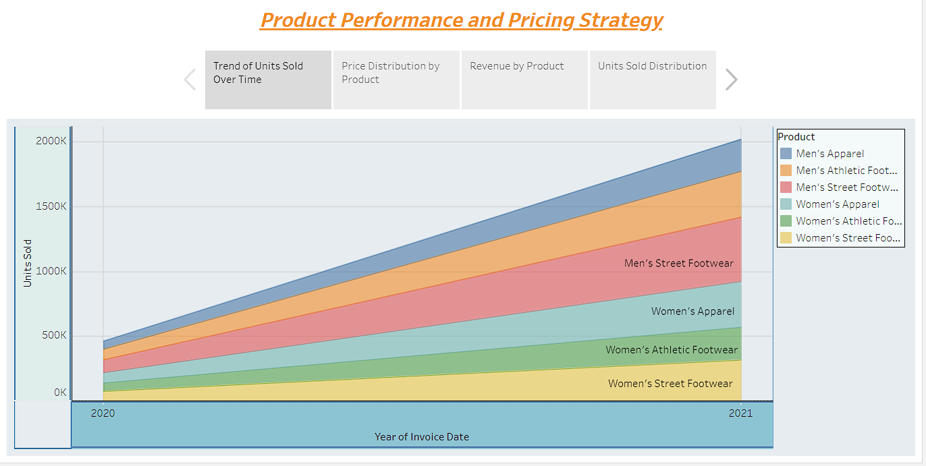

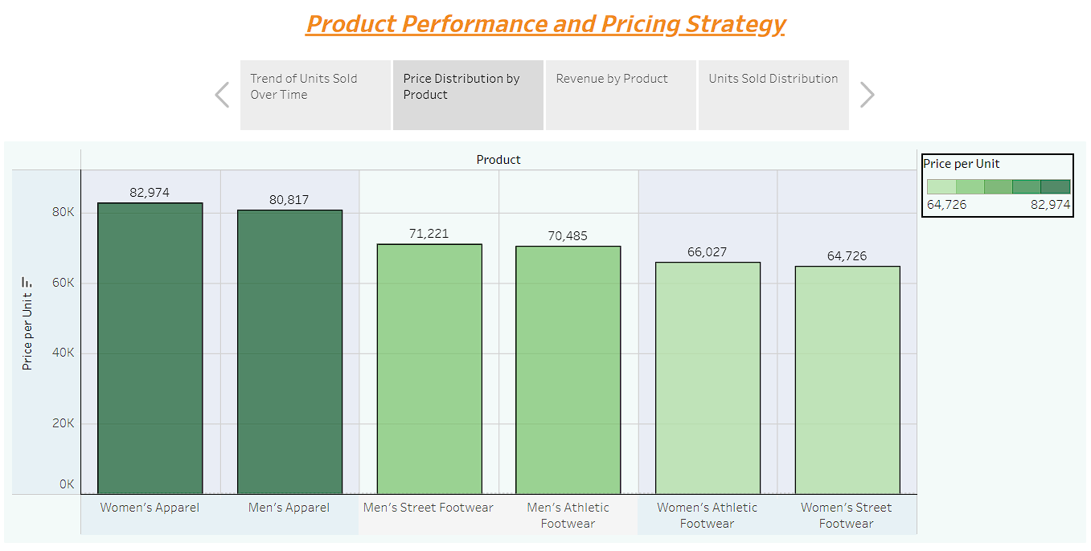

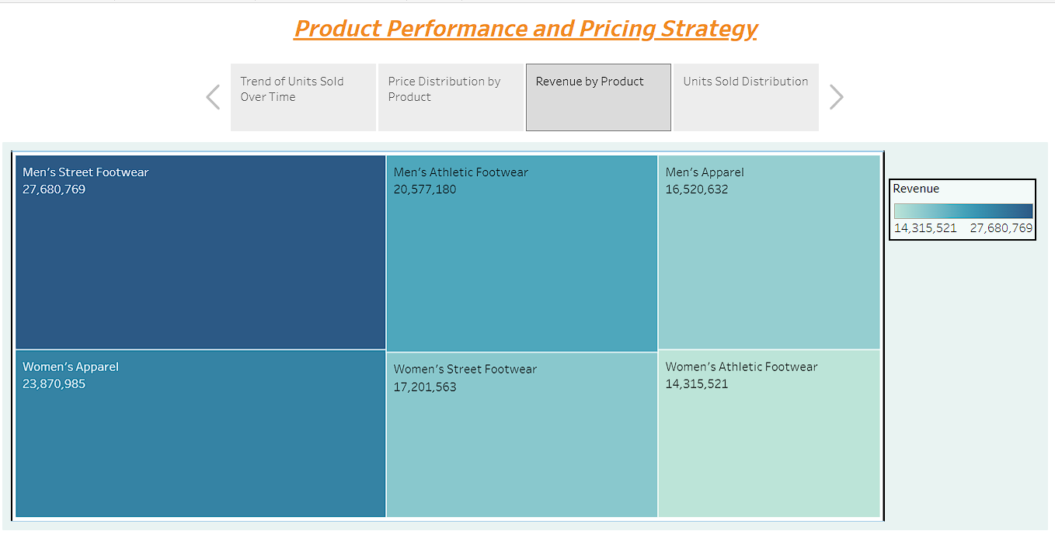

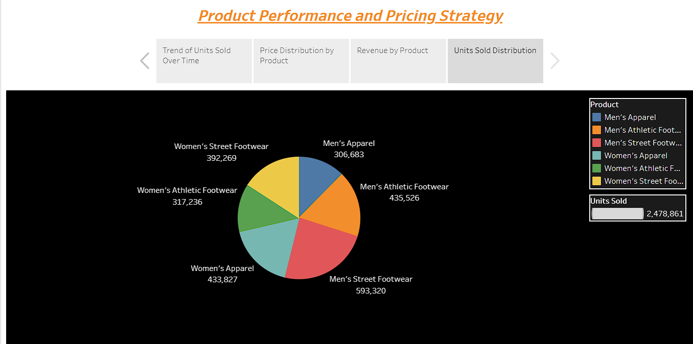

**FINAL CONCLUSION:**

**Summarized purpose:**

The primary objective of the Retailers Performance Analysis is to provide Adidas with a comprehensive, data-driven understanding of their sales and business performance across various critical dimensions. This analysis encompasses geographical sales distribution, financial health, retailer profitability, regional performance, product insights, pricing dynamics, and historical trends. The purpose is to empower Adidas to make strategic decisions in marketing, retail partnerships, inventory management, pricing, and overall business strategy.

**Summarized conclusion:**The Retailers Performance Analysis utilizing the 16 graphs provides Adidas with a wealth of detailed insights to drive strategic decisions across their retail operations. Here's a summarized conclusion with minute details:

**Geographical Sales Analysis (Graph 1):** Insights from this analysis help Adidas identify key cities with high sales, enabling the optimization of marketing strategies and inventory management.

**Financial Health Assessment (Graph 2**): Tracking operating margin trends over time empowers Adidas to assess the financial health of the business, recognizing profitable periods and areas that may require operational improvements.

**Retailer Profitability (Graph 3):** The analysis of retailer profitability in relation to units sold guides strategic retailer partnerships and incentive programs.

**Regional Performance Evaluation (Graph 4):** Comparing total sales across regions assists Adidas in efficient resource allocation and targeted strategies for regions with room for growth.

**Retailer Insights (Graph 5, 6, 7, 8):** These graphs provide a comprehensive view of retailer performance, including profitability, regional sales, and operating profit margins, informing decisions for optimized retailer partnerships and overall profitability.

**Pricing and Units Sold (Graph 9):** Understanding the relationship between price per unit and units sold in different regions supports pricing strategies and ensures that units are sold in line with market dynamics.

**Product Insights (Graph 10, 14, 15):** Analysis of top-selling products, price distribution, and product revenue guides product development, pricing strategies, and marketing efforts.

**Trends and Historical Performance (Graph 11, 12, 13):** Tracking historical trends in total revenue, regional revenue distribution, and unit sales over time informs sales and inventory strategies, while identifying regions with potential for growth.

**Unit Sales Distribution (Graph 16):** Showcasing unit sales distribution by different product categories guides inventory management and marketing strategies, ensuring that different product categories are managed effectively.

In conclusion, the Retailers Performance Analysis arms Adidas with a comprehensive set of data-driven insights to enhance their retail operations. It provides detailed, actionable information for optimizing marketing, retail partnerships, inventory management, pricing, and overall business strategy. These insights, based on minute data details, result in improved sales, profitability, and competitiveness in the market, allowing Adidas to maintain a strong market presence and adapt to evolving market conditions.